Veterans Middle School
G Suite Training
Region One Workshop #98302

8:00 AM-10:00 AM Group 1
COLLABORATION APPS (G Suite)
- Drive
- Docs
- Forms

10:00 AM-12 PM Group 2
COLLABORATION APPS (G Suite)
- Drive
- Docs
- Forms

12 PM - 1:30 PM LUNCH

1:30 PM - 3:30 PM Group 3
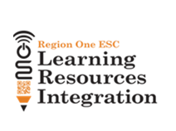
COLLABORATION APPS (G Suite)
- Drive
- Docs
- Forms

